**Level 2 guidance for businesses that provide indoor sport and recreation facilities and services**

**WHO DOES THIS GUIDANCE APPLY TO & SCOPE**

Indoor sports and recreation facilities play a vital role in ensuring the ongoing health and wellbeing of Islanders. A managed continued return to indoor activity, whilst ensuring that public health measures are maintained, will benefit both mental and physical wellbeing. However, the safety of customers, staff, volunteers and their families remain the absolute priority.

This is guidance for businesses, clubs and associations that operate indoor sport / recreation facilities and / or provide indoor sport/ activity services (‘indoor activity businesses’). It supports operators in identifying how they can adapt their practices to significantly increase safety for staff, volunteers and customers / users in the face of COVID-19.

There is separate guidance for businesses that provide outdoor sport and recreation facilities and services insert hyperlink.

It is important to remember and consider all ongoing health and safety considerations, especially at a time where businesses / venues are not operating as normal and where staff, who normally take responsibility for particular aspects of risk management, may not be present.

The guidance provides the basis for each operator to develop their own operating guidance for customers, staff, volunteers and supply chains. It helps you to consider the risks and mitigation measures that you will need to put in place to address COVID-19 and also the day-to-day operational risks.

It is not intended to be exhaustive in covering every possible scenario but aims to provide a clear direction for the sector. Nor is it intended to cover all aspects of every business. There will be special undertakings for those with specific offerings and professional bodies have been very proactive in providing advice that operators should refer to and cross check to any locally specific guidance / wider pandemic public health policy.

In looking to guidance elsewhere operators should recognise that Jersey may be recommending slight differences in approach due to our particular COVID-19 policy and local requirements and legislation. This guidance represents the absolute minimum standard operators might adopt.

Businesses, sports clubs and associations can make their own decisions and can go above the standards within this guidance, particularly where professional accreditation bodies or similar require it. However, they cannot go any lower.

This guidance applies to all businesses / venues that operate indoor sport and recreation facilities, which include, but is not limited to, the following:

* **Relatively ‘low-intensity’ indoor sport or recreational facilities** - Please see Appendix one for a full definition of low-intensity - During low-intensity activity / exercise, you should be able to comfortably carry out a conversation or be able to sing a song, without breathing heavily. You may start to feel warm but should avoid becoming sweaty;
* **Businesses offering training/tuition in relatively low-intensity activities that are conducted indoors** – e.g. lower risk activities that, with planning, can take place with participants and instructors maintaining a distance of two metres from each other, e.g. Pilates classes and personal training (provided the activities undertaken are done so at ‘low-intensity’);
* **The indoor aspects of after school clubs** - provided that both the guidelines given here and the guidance for schools and clubs INSERT HYPERLINKS is followed;
* **Indoor swimming pools** – Venues should be aware that swimming should be low-intensity and operate pools to ensure physical distancing is possible. Users should be reminded of these measures. It is highly recommended that operators base their risk assessments and operating procedures on the Swim England ‘Return to the Pool’ draft guidance ([www.swimming.org](http://www.swimming.org)). However, changing rooms and shower facilities **must remain closed**.

**GENERAL PRINCIPLES FOR OPENING AT LEVEL 2**

This guidance is in addition to:

* The general public health guidance (insert hyperlink) that outlines the key principles to supress virus transmission through physical distancing from people they do not live with and respiratory and hand hygiene;
* The general guidance that applies to all businesses which covers general hygiene, looking after your staff, physical distancing and how you can safely take payments, manage queues, manage disinfecting touch points, set up booking systems and times slots etc;.
* Any other guidance that might apply to services or facilities that are offered in a multi-functional venue e.g. retail, office space, food.

If you cannot follow the general public health, business advice or other related guidance then you should not open.

In opening a sporting or recreational service, particular consideration should be paid to the following important principles that are critical to supressing virus transmission in sport and activity environments:

* Ensuring that it is possible to maintain **two metres physical distancing** between people who do not live together throughout the activity. E.g. it is unlikely to be possible to maintain two metre distance in many small court based games;
* Ensuring that the room / court itself or any unavoidably shared equipment can be **sufficiently disinfected** for example gym equipment may be used (at low-intensity) if the room is well ventilated and sufficient disinfecting is possible between users not from the same household;
* Ensuring the activity is **low-intensity** (please see Appendix one for a full definition of low-intensity) and carried out in a well-ventilated area. This is very important because in higher-intensity activity, water droplets arising from sweat or heavy breathing are easily spread between participants who may be in a relatively enclosed indoor space even if they are spaced at two metre distances and this creates an increased risk of virus transmission.

Jersey Sport is also able to help and further information is available on their website (INSERT hyperlink to Jersey Sport)

Islanders can spend time outdoors undertaking controlled events like organised sports, community and group activities with a maximum of up to 40 people. (INSERT hyperlink to gatherings advice)

**PREPARING TO RESUME INDOOR SPORT AND RECREATION BUSINESS AT LEVEL 2**

You should undertake a risk assessment and put a plan in place and make it widely accessible to your staff, volunteers and customers.

The involvement and commitment of your staff and volunteers will be key to reducing risk for everyone. Before a setting opens, they will need to understand how to minimise the risk of the spread of COVID-19; your new operating procedures and where appropriate be provided with training.

In developing a specific plan for your setting consider:

* Ensuring your plan, processes and systems meet the overarching public health requirements Insert hyperlink to public health info;
* Ensuring your plan, processes and systems meet the overarching advice for businesses and indoor workplaces. Insert hyperlink;
* Ensuring safe facility and participant practices, like hygiene practices and limiting shared equipment as much as possible;
* Being prepared for the management of an individual with COVID-19 symptoms;
* How you will administer first aid to someone Insert hyperlink;
* If a venue with multiple functionality in addition to the primary activity e.g. food areas, retail, can safely open all its services and at what capacity;
* Where premises have remained closed during the lockdown period, appropriate health and safety checks should be conducted prior to reopening. This includes being Legionella aware; INSERT hyperlink
* How you will manage toilets facilities to maintain hygiene and physical distancing; INSERT hyperlink
* Encouraging individuals to take reasonable personal responsibility when taking part in physical activity e.g. using their own equipment and water bottles and towels etc as much as possible;
* Establishing protocols for rotating or sanitising any shared equipment;
* Maintaining rigorous cleaning procedures and ensuring staff carry out regular cleaning of high-contact touch points throughout the premises;
* Personal lockers should not be used due to the difficulties in maintaining hygiene and physical distancing;
* Any equipment that is in use for low-intensity activities must be two metres apart
* Touch points of equipment should be cleaned immediately after use – this can be done either by the customer/user or staff NB this is in addition to the cleaning schedule;
* Physical distancing and cleanliness will be promoted by the instructor(s) at the beginning and throughout all classes;
* Small group classes will be organised in a series of formations to comply with physical distancing, with appropriate spacing between participants monitored by the instructor throughout the class/activity;
* Nothing will be passed to/from the instructor to the user – including personal items, water bottles, bibs etc;
* We recommend a sufficient gap between users of rooms for aerosols created by the breathing of previous users to settle (20 minutes minimum) and then for disinfecting, cleaning and drying of surfaces to occur;
* Ensure that the period of time between classes does not cause bottlenecks of customers in waiting areas where social distancing might become difficult;
* Equipment (including mats etc.) will be cleaned in between use. This can either be done by the customer/user or staff member and monitored;
* All visitors/contractors must follow the physical distancing and cleanliness guidelines;
* You should also be mindful of information and stipulations from your insurers.

**SECTOR SPECIFIC EXCEPTIONS**

**Changing rooms / shower facilities** – They should not open as they are considered higher risk areas for virus transmission. This is because of the difficulties in physically distancing between multiple and potentially concurrent users and the challenge of sufficiently disinfecting between users.

Toilets or other areas must not be allowed to become used as changing rooms and should be monitored to ensure this is not the case.

A ‘play and go’ or ‘beach-style’, ‘swim and go’ approach should be encouraged when undertaking indoor sport or recreational activities. Users should be encouraged to arrive in their kit, ready to participate and then shower and change their clothing at home.

**Soft play areas** – They should not open as there are multiple touch points which cannot be sufficiently disinfected and physical distancing in these facilities is very difficult.

**Jacuzzis, hot tubs, and other spa-type small static-use indoor ‘pools’ and saunas steam rooms** – These should not open as physical distancing is difficult due their size.

**APPENDIX ONE - What is meant by ‘low-intensity’ activity**

The concept of low-intensity activity is very important for recommencing indoor sport and recreational activities. This is because the virus is spread between people through droplet transmission. Heavy breathing or sweating as a result of more intense activity raises this risk considerably and so activities that cause heavy breathing or sweating indoors are strongly discouraged and should not recommence.

To help you with your risk assessment we define low-intensity activity as follows:

During low-intensity activity / exercise, you should be able to comfortably carry out a conversation or be able to sing a song, without breathing heavily. You may start to feel warm but should avoid becoming sweaty.

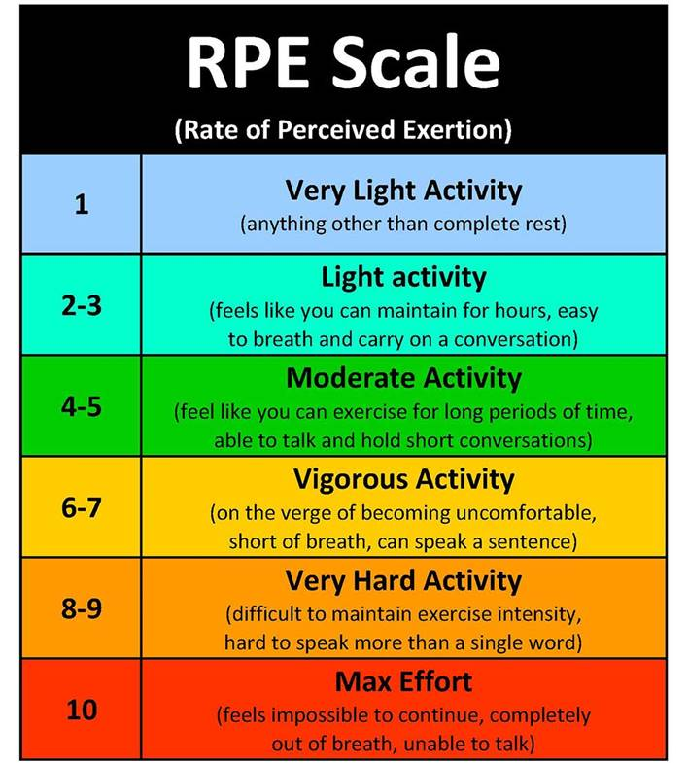This is further explained in the RPE Scale below where an exertion level between 1-3/4 i.e. ‘very light activity and ‘light activity’ would be considered to represent low-intensity exercise. Anything within 4/5 and above falls outside the definition of ‘low-intensity’ exercise and is strongly discouraged.